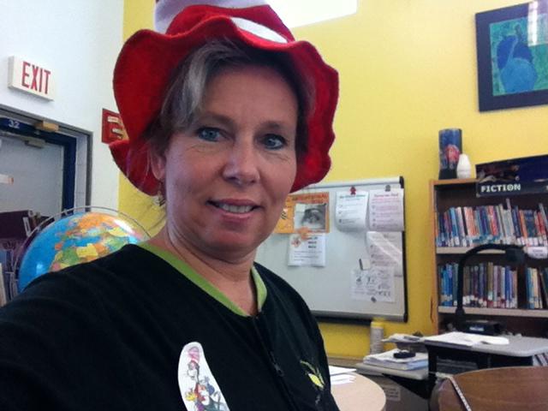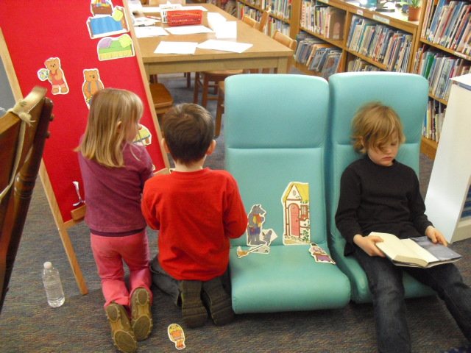

3901 Red Hill School Rd.

North Garden, VA 22959



[http://www2.k12albemarle.org/school/RHES/library/Pages/default.aspx](https://www2.k12albemarle.org/school/RHES/library/Pages/default.aspx)

Miss Rondeau is here to help you find answers, information and with reading questions! ☺

434-293-5332 Ext 31017

Parents: Interested in checking books out, come see me!

**Raising Readers 10 Easy Steps**

1. Read aloud.

2. Talk about books you read.

3. Keep books and magazines around the house.

4. Give books as gifts.

5. Obtain a public library card for your child.

6. Schedule regular visits to the library.

7. Help your child create and illustrate a book.

8. Reread a book you loved as a child, and then share it with your child.

9. Make reading a daily event at home.

10. Organize a home library.

**Red Hill School Library Media Center**

**TODAYʼS READERS ARE TOMORROWʼS LEADERS!!**

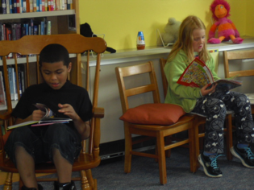

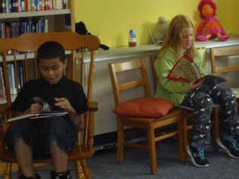

**SUBSCRIPTION DATABASES**

Please see the handout in the library for user id and password codes. The following is a list of available online resources to RHES students and staff:

1. BrainPop 2. Choice Literacy

3. Culture Grams 4. Webster’s Dictionary 5. Discovery Education Streaming 6. Duke Digital Collection 7. World Book 8. Encyclopedia of Virginia

9. Explore Learning (Gizmo)

10. Find It Virginia 11. World Data Analyst

12. Historical Newspapers 13. eLibrary

14. Britannica Online School Edition

15. Reading A-Z

16. Thinkfinity 17. TumbleBooks

18. World Book Online



**OVERDUE AND LOST MATERIALS**

If materials become lost or damaged while they are circulating, we ask that you pay the replacement cost of the item. Just check at the circulation desk if you wish to know what a material costs.

Periodically, students will come home with overdue notices. These are not bills, but are just a reminder that a material is checked out and needs to be returned.

Bills for overdue or damaged materials will need to be settled up before the end of the school year in June.

**ANNUAL EVENTS**

Read Virginia Readersʼ Choice Books- September to April

Childrenʼs Book Week and Book Character Day- October

Book Fair - December

Read Across America- Dr. Seuss- March 2

Virginia Festival of the Book - March

National Library Month - April Book Fair – April/May

Summer Reading List - June

**WHATʼS IN OUR LIBRARY FOR YOU?**

**Library Mission Statement**

The mission of the library program at Red Hill Elementary School is to ensure that all students and staff are effective searchers and users of ideas and information. The library provides access to information, instruction, resources, and activities that will contribute to lifelong learning.

**Library Goals and Objectives**

**Goal** - Students and staff will be able to access information in the library media center independently.

Objectives - -provide learning activities to familiarize the students and staff with the on-line catalog. - -provide learning activities which will develop an understanding of how information can be found, organized, selected, and presented.

**Goal** - Students and staff will read for pleasure.

Objectives - -create an atmosphere that fosters the pursuit of reading for pleasure. -provide programs that expose students to a wide range of materials for recreational reading.- - provide a diverse collection for students/staff to use for pleasure and instruction. -provide opportunities to excite and stimulate students/staff to enjoy and read.